Andrea Khoury

queries for the pizza database

1. Find all pizzerias frequented by at least one person under the age of 18.

SELECT Pizzeria FROM Frequents NATURAL JOIN Person WHERE age <18

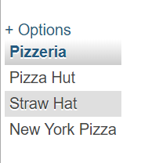

1. Find the names of all females who eat either mushroom or pepperoni pizza (or both).

SELECT DISTINCT name FROM Eats NATURAL JOIN Person WHERE gender=’female’ AND (pizza= ‘pepperoni’ OR pizza = ‘mushroom’)

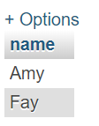

1. Find the names of all females who eat both mushroom and pepperoni pizza.

SELECT name FROM Eats NATURAL JOIN Person

WHERE gender='female' AND pizza= 'pepperoni' AND name in (SELECT name FROM Eats NATURAL JOIN Person

WHERE gender='female' AND pizza= 'mushroom' )

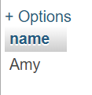

1. Find all pizzerias that serve at least one pizza that Amy eats for less than $10.00.

[SELECT](http://136.183.56.190/phpmyadmin/url.php?url=http://dev.mysql.com/doc/refman/5.5/en/select.html) Pizzeria FROM ([SELECT](http://136.183.56.190/phpmyadmin/url.php?url=http://dev.mysql.com/doc/refman/5.5/en/select.html) * FROM Person WHERE name='Amy') AS p NATURAL JOIN Eats NATURAL JOIN ([SELECT](http://136.183.56.190/phpmyadmin/url.php?url=http://dev.mysql.com/doc/refman/5.5/en/select.html) * FROM Serves WHERE price < 10) AS s

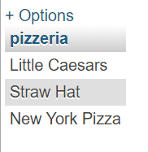

1. Find all pizzerias that are frequented by only females or only males.

[SELECT](http://136.183.56.190/phpmyadmin/url.php?url=http://dev.mysql.com/doc/refman/5.5/en/select.html) DISTINCT Pizzeria FROM Frequents NATURAL JOIN Person WHERE gender = 'male' [AND](http://136.183.56.190/phpmyadmin/url.php?url=http://dev.mysql.com/doc/refman/5.5/en/logical-operators.html#operator_and) pizzeria [not](http://136.183.56.190/phpmyadmin/url.php?url=http://dev.mysql.com/doc/refman/5.5/en/logical-operators.html#operator_not) [in](http://136.183.56.190/phpmyadmin/url.php?url=http://dev.mysql.com/doc/refman/5.5/en/comparison-operators.html#function_in) ([SELECT](http://136.183.56.190/phpmyadmin/url.php?url=http://dev.mysql.com/doc/refman/5.5/en/select.html) Pizzeria FROM Frequents NATURAL JOIN Person WHEREgender = 'female') UNION ALL [SELECT](http://136.183.56.190/phpmyadmin/url.php?url=http://dev.mysql.com/doc/refman/5.5/en/select.html) Pizzeria FROM Frequents NATURAL JOIN Person WHERE gender = 'female' [AND](http://136.183.56.190/phpmyadmin/url.php?url=http://dev.mysql.com/doc/refman/5.5/en/logical-operators.html#operator_and) pizzeria [not](http://136.183.56.190/phpmyadmin/url.php?url=http://dev.mysql.com/doc/refman/5.5/en/logical-operators.html#operator_not) [in](http://136.183.56.190/phpmyadmin/url.php?url=http://dev.mysql.com/doc/refman/5.5/en/comparison-operators.html#function_in) ([SELECT](http://136.183.56.190/phpmyadmin/url.php?url=http://dev.mysql.com/doc/refman/5.5/en/select.html) Pizzeria FROM Frequents NATURALJOIN Person WHERE gender = 'male')

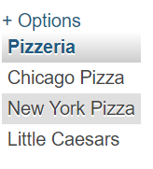

6. For each person, find all pizzas the person eats that are not served by any pizzeria the person frequents. Return all such person (name) / pizza pairs.

7. Find the names of all people who frequent only pizzerias serving at least one pizza they eat.

8. Find the names of all people who frequent every pizzeria serving at least one pizza they eat.